SRA 2020: Risk Science for Sustainability

Plenary Session: “Sustainability, Risk and Environmental Justice”
The United Nations Sustainable Development goals recognized that we will not achieve a truly sustainable future without paying careful attention to the linked challenges of environmental and social justice. The reality is that often the greatest environmental health impacts are experienced by the most marginalized communities. The risk sciences are critical to understanding who disproportionately bears these risks, how to communicate these risks effectively, and ultimately how to build systems to reduce these inequities.

Dr. Chief presented on “Community-driven University Partnerships to Assess Exposures and Risk Perceptions following the Gold King Mine Spill,” describing her study of the impacts of a 2015 mine spill on residents of the Navajo Nation. Her team’s research aimed to understand the short-term exposures to the spill, assess the extent and presence of contaminants for one year, and understand the risk perceptions of the Navajo communities affected.

What happened?
On August 5th, 2015, a crew from the Environmental Protection Agency accidentally released three million gallons of acid mine drainage into the Animas River. The spill traveled downstream, turning a 275-mile stretch of river that is part of the Navajo Nation a shocking yellow-orange. The contamination of a major water source is no light matter-- especially in the water-stressed Southwest. “Yet the depth of the devastation and trauma to Navajo families living along this 275-mile stretch of the river has been largely marginalized and ignored,” said Chief. “Imagine waking up to turn on the faucet only to see yellow water coming out….This experience would cause worry, fear, and stress as you tried to search for answers.”

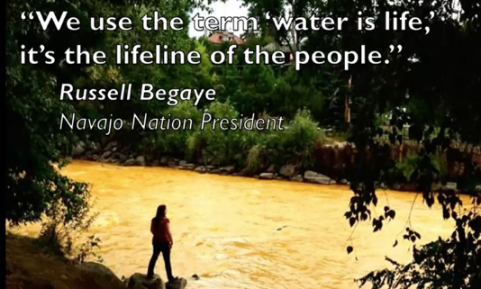
The importance of water for the Navajo people
The Navajo communities that depend on the Animas River weren’t informed until days after the spill, that the plume was coming their way. Suddenly the only source of water they used for planting, prayer and ceremony - for basically maintaining their way of life - became toxic, contaminated. Elders worried about their sheep that graze along the river and drink its water. They were also concerned about their corn, a sacred staple. “As a result of the spill, a way of life was horribly disrupted in ways that perhaps can never be truly quantified,” said Chief.

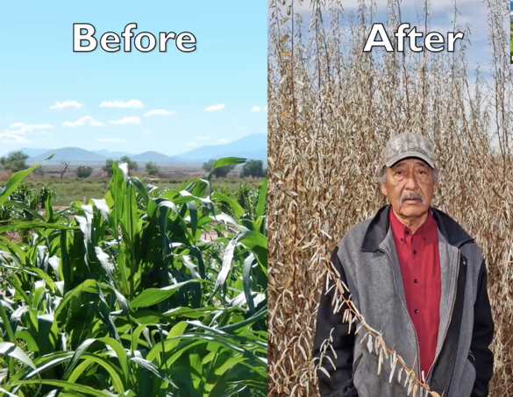
The disaster happened in the weeks leading up to the harvest, which meant that 700 families lost their valuable crops. The farmers didn’t understand why this breach wasn’t predicted or why it had happened. Chief said it was difficult to explain to the elders, who primarily speak Navajo, the risks they faced as they watched their crops die. “The only thing that was clearly felt and understood was profound loss and betrayal,” she said.

The importance of cultural knowledge in assessing environmental risks
Part of the problem was that a risk assessment for “recreational use” did not fully capture how the Navajo people use the river. As Chief explained, the Dine’ people have lived alongside the river for centuries and use it in every part of their lives: for farming, feeding their livestock, and sustaining plant life along the riparian corridor that they use for hunting and cultural and ceremonial purposes. Chief quoted Navajo Nation President Russell Begaye: “We use the term ‘water is life,’ it’s the lifeline of the people.”

According to Chief, this environmental catastrophe showed that it is essential to recognize individual hazard disparities. “It’s important to consider all the exposure pathways for diverse populations and the sorts of ways they might engage with resources or be exposed to these hazards.”

Environmental scientists need to “consider cultural aspects within our work, not just be so one-dimensional about our science, but really be more holistic, to think about it systematically and be transdisciplinary,” said Chief. “Working with our colleagues across disciplines can help us answer these questions more holistically.”

Community involvement in research
To build back trust, Chief and her colleagues nurtured their community partnerships and listened to the concerns and advice of the Navajo people. “They drove the research questions in this study,” said Chief.

Listening sessions were held in three different communities. They revealed that people did not trust scientific research, especially because their livelihoods and perspectives had not been considered. They also feared that their water wasn’t safe and were concerned about future impacts on the river. They were frustrated that there were no decision-making protocols, and feared they would not see the data.

“We were careful to listen to the perspectives of the Navajo people in a way that was culturally sensitive,” said Chief. The team was also sensitive about collecting blood and urine samples to test for exposure. Community health representatives (CHRS) were trained to collect this data and administer questionnaires about each individual’s work and activities. “We were happy to see that exposure to the spill was not present,” said Chief.

Communicating science to the local people
For risk perception research, the team conducted focus groups with young adults, adults, and elders. They asked them to describe their impacts from and concerns about the spill, and their visions of the future. There were common themes involving exposure, distrust, cultural and mental health impacts, and physical and financial impacts. The team presented their findings to the community in a culturally appropriate way by creating a module the Navajo people would understand. To do this, they categorized the impacts in terms of the four directions: East for spiritual wellness, West for family and community, North for environment, and South for economic livelihood.

“All of this was framed within the Navajo context of problem solving, which involves critical thinking, planning, implementation, and reflection,” said Chief. “So we made an effort to make sure we are doing our best to contextualize and bring everything into the Navajo worldview and cultural context.”

Many of the scientists involved with the project were accompanied by translators, but some important terms were not standardized—creating confusion among community members. To fix this, the team worked with community partners to standardize key terms such as exposure, mine drainage, and biomonitoring. “This allowed us to accurately translate our science into the Navajo language,” says Chief. They also needed to translate the meaning of parts per billion (ppb) when explaining chemical exposure risk. To do this, they used an analogy familiar to the Navajo: a 50-gallon water barrel. An illustration showed community members that “ppb” is equivalent to one drop in 250 barrels of water. They also created visual diagrams with pictographs to describe differences between the standards of water use such as agriculture, livestock, and drinking water.

From a communication standpoint, researchers must make sure they are translating the science and the impacts for all impacted populations, not just focus on the majority. “Science communication is important in our work with the Navajo people,” says Chief. “Language can be a barrier when non-Navajos are disseminating scientific information.”

Acknowledging the mental impacts of environmental risks
The psychological trauma of environmental catastrophes like the Gold King mine spill needs further study, according to Chief, adding that her study only touched on the mental health impacts of the river contamination. Three weeks after the spill, suicide spiked with 15 Navajos taking their own lives. “This is something that has long-lasting impacts,” said Chief.

She points out a previous study that showed there were “huge” mental impacts on Alaskan Natives when they were unable to engage in cultural activities due to a major oil spill. “This is a theme amidst Indigenous communities,” said Chief. “It doesn’t just go into environmental or water quality contamination but extends into the mental health and cultural health impacts. We definitely need more research around that.”

Preparing for the next spill
The Gold King mine spill was a “wake-up call,” said Chief. “Another spill may happen. This is the wicked problem. Within this region, there are over 11,000 abandoned mines -- in Colorado alone.”

“Our research showed that creating a response model that addresses all the concerns of those impacted would be important to ensure that timely decisions are made — so that we’re not adding to or compounding the risk and trauma that they feel,” said Chief. “The local community must be involved in developing this model. It’s important to empower people to respond to an environmental catastrophe like this in a just way – contributing to their resilience.”

Environmental Justice. What needs to change?
Like so many communities that are disproportionately impacted by environmental risks, “Indigenous peoples continue to be marginalized and not given their rightful place at the table regarding decision making, action and mitigation with environmental injustices,” said Chief. She pointed out that in New Zealand, the country has given peoplehood rights to the river. A Maori person can represent the river’s rights at the national level.

“If Indigenous peoples could be given that voice at the national level in the United States, that could really make a difference in the protection of rivers as it relates to the health and environment of Indigenous lands,” said Chief. “Right now, in the U.S., there’s little voice of tribal nations in Congress and at the US Senate level. Indigenous people need to be at the table to help mitigate these environmental injustices.”

How can risk scientists make a difference?
“I think your role is very critical and can really impact our communities,” said Chief. “Many of you experts know the details of exposure model risk assessment. I encourage you to continue doing the great work that you do, but also to be aware of the cultural aspects when you’re doing this work. To be really considerate of other types of worldviews and uses and exposure pathways that can come about as a result of the culture and the context of the communities that could be impacted by a lot of these risk assessments.”

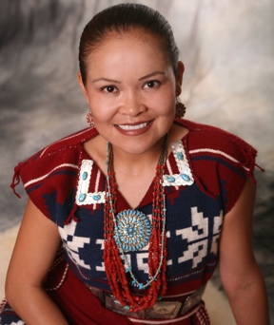
Dr. Karletta Chief

Karletta Chief is a Dine′ hydrologist and Associate Professor and Extension Specialist in the Department of Environmental Science at the University of Arizona in Tucson, AZ. As a Navajo woman, she identifies as Bitter Water. Dr. Chief received her B.S. and M.S. in Civil and Environmental Engineering from Stanford University, and her Ph.D. in Hydrology and Water Resources from the School of Engineering at the University of Arizona. Chief is known for her work to address environmental pollution on the Navajo Nation and to increase participation of Native Americans in STEM. One of her research interests is addressing food, energy, and water challenges in indigenous communities with methods that include their traditional values. She gives public presentations in the Navajo language especially to farmers, ranchers, and families that are affected by pollution from mining waste.

This project was funded by the National Institute of Environmental Health Sciences (NIEHS R21 ES026948), the University of Arizona Agnese Nelms Haury Program in Environment and Social Justice, University of Arizona Superfund Research Program (NIEHS P42 ES004940), Southwest Environmental Health Sciences Center (NIEHS P30 ES006694), Center for Indigenous Environmental Health Research (NIEHS P50ES026089 and EPA R83615), National Heart, Lung, and Blood Institute (K25 HL103970, granted to PI Beamer), and Center for American Indian Resilience (NIMHD P20MD006872). This publication’s contents are solely the responsibility of the authors and do not necessarily represent the official views of the National Institutes of Health or the Environmental Protection Agency.

It is a partnership between several universities located in and around the Navajo Nation. A diverse set of investigators and community partners worked on the team with expertise in social, environmental, and health sciences.

